**Firefox Settings**

1. In Firefox, go to the “hamburger” icon:

cid:image003.png@01D04D01.F2234C50

2. Then Options:

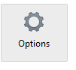

3. Then disable “Use hardware acceleration when available”

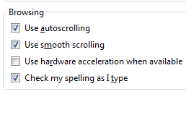

4. Then go to Privacy:

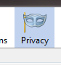

5. Click on Settings to get the dialog box below. Check cache and choose OK.

